Associated Text for the
Enhanced Training MOB Course
for
Skilled Offshore Teams

Slide 1: Welcome
Hello and welcome to the Cruising Club of America’s Practice Enhanced Training MOB Course for Highly Skilled Offshore Teams. The course is designed to assist you in reviewing and performing MOB rescue techniques on your boat with your crew.
The course is divided into a classroom or home study portion, followed by two on-the-water exercises.
The classroom portion is not intended to “teach” new MOB rescue techniques or rewrite existing protocols. It is, however, designed to provide a forum for reviewing the solid work of experts using a selection of videos and articles required for the course prerequisites. There are many excellent training materials available, and this course intentionally builds on, not replaces, these outstanding efforts.
The practical exercises provide the “doing,” with your crew on your boat - not just viewing videos and reading articles. Confidence and muscle memory are then earned through action and practice. This is the primary focus of this course. When faced with a life-threatening emergency situation, the time you have spent practicing will prove vital.
Thank you for choosing to up your safety game by assembling the required equipment and completing all course prerequisites. You are ready to continue on with this course.
If you and your crew still need to complete the prerequisites – STOP.
The course video and articles provide a basic understanding of the course and the techniques being used, and skipping this requirement will not yield the desired outcome. Please complete all of the prerequisite materials before continuing.

Slide 2: Desired Outcomes
Dealing with a life-threatening emergency is extremely challenging; success demands physical and mental preparation and practice. Otherwise, fear and uncertainty may lead to a less-than-desirable outcome. How ready and really prepared are you if your crewmate or skipper goes overboard? A crew that has practiced successful rescue techniques on your boat gains confidence and muscle memory, vital elements of a successful rescue.
Therefore, the desired outcomes from this course are “Yes” responses to these three questions.
  - Are you ready and prepared?
  - What rescue plan (do you think) works on your vessel?
  - Have you practiced your rescue plan as a team?
Have you practiced your rescue plan under race conditions, successfully returned to a MOB dummy in 6-8’ seas with 20-25 knots of wind, and practiced a hoist method to lift your 180-pound crewmate aboard?
This is the desired outcome.

Slide 3: MOB Basic Rescue Principle
Without question, the most important point is not to fall off your boat. It is the skipper's responsibility to develop buy-in and full cooperation from the crew to foster an onboard Culture of Safety. Effective leadership impacts all vessel procedures and rules.
Ralph Naranjo has written in his book, The Art of Seamanship: “A proﬁcient skipper must be as multifaceted as possible, not just in breadth of knowledge but also in the kind of wisdom that’s acted out on the pitching deck of a vessel at sea” (Naranjo, 2015).
Effective skipper leadership develops a crew that works together within vessel protocols and standards, and fosters a team that looks out for its mates and the ship. Safety protocols must be established, reviewed, modeled and followed. It is not appropriate for one crew member to opt out. We have all heard this standard excuse: “It’s ok, I am a good swimmer, and it is hot today. So I won’t wear a PFD." Behavior like this places the whole crew at risk and must not be tolerated. It is the everyone’s responsibility to take care of one another.
Wearing PFDs should be the norm on your vessel. Every crew member must know their gear. Gear should be routinely inspected at least annually.

Slide 4: MOB Basics – CCA Life Jacket and Tether Statement
Stay Onboard; if not, Stay Afloat!
Wearing a life jacket and tether when on deck and underway is part of a vessel’s Culture of Safety. When operating in warm waters, in daylight, and in calm conditions, virtually any approved life jacket will work. When conditions are more challenging, an offshore life jacket plus tether becomes the “right tools for the job.” It’s vital that you not only have sufficient buoyancy for rough conditions but that you remain attached to the vessel by means of a tether. This greatly reduces the chance of going overboard when rescue may be challenging for your crew.
The use of tethers is recommended under the following conditions:
- Sea conditions: large waves, heavy winds, cold water, and confused seas.
- Low visibility conditions: nighttime, fog, heavy rain, large seas.
- Crew limitations: shorthanded, less experienced, lack of training, age, and fitness.
- Vessel design: boats with fewer protected spaces, sailing at greater angles of heel, smaller or lighter displacement sailboats with quicker motions

Slide 5: 11 Step MOB Rescue Process
There are a host of issues and conditions that must be quickly addressed in an emergency MOB situation: Fear, panic, and the feeling of being overwhelmed are foremost. Training and practice can dramatically help reduce these paralyzing feelings.
This course will provide the training to develop and practice this 11 Step MOB Rescue Process for your crew on you boat.
Trained emergency responders take 10 seconds to address these feelings – take a breath, think through what is happening, assess your situation, plan out your action steps. Think Throw – Bark – Mark – Park. Let your training take over.
Throw overboard your boat's MOB gear and other items that float.
Bark “Man Overboard” as your first oral response - even if no one else is on board.
Mark your position on your chart plotter, activate the VHF DSC Red Emergency Button, and helm a short squiggly course as a visual aid. Assign the task of spotter to a crew member as soon as possible.
Park the boat as quickly as possible. Separation distances between the vessel and PIW can extend quickly. At only 5 knots, your boat will cover over 500 feet in 1 minute. Therefore, parking the boat, getting the sails down or hove-to, and dealing with weather and sea conditions are valuable components of your rescue effort. Maintaining visual contact with the PIW can be extremely challenging, and the time taken to minimize forward progress is time well spent.
It may be overused, but the Navy SEALs' mantra of “Slow is smooth, smooth is fast” is very applicable to your MOB rescue. In high-stakes situations, efficiency and speed come from deliberate actions. Fast is important, but just being fast can lead to mistakes, and mistakes can lead to undesirable outcomes. Smooth and steady only come from practice.
Return to the PIW - it is not only ok but recommended to use your engine. Make sure there are no lines in the water, as a fouled propeller will only add to the difficulty and confusion. Be in neutral when the PIW is alongside.
Circle the PIW - After deploying the Lifesling circle the PIW to permit the PIW to grab the yellow retrieval line and the flotation collar. A sharp fishhook turn is best, keeping your boat a safe distance from the PIW.
Stop the boat when the PIW makes contact with the LifeSling or yellow haul line so as not to drag the PIW through the water.
Pull the PIW towards the vessel: manually pulling the PIW to the vessel with the yellow retrieval line protects the PIW from being overrun by the boat. Steering the boat close to a PIW is very risky and ill-advised. Boats are heavy, and in a seaway their motion can be unpredictable and dangerous to a PIW.
Secure the PIW to the vessel: Once the PIW is alongside, secure the PIW to minimize bouncing while finalizing the onboarding rig layout. This time should be kept to a bare minimum as the PIW is in a high-risk position
Onboard PIW using your tested onboarding technique. Safely lift the PIW out of the water and onto the deck. Your onboarding technique will be determined through this training exercise.
Medical assessment: Perform a quick assessment of the medical status of the PIW and address any presenting conditions.

Slide 6: Review Onboarding Techniques
The best onboarding technique is the one that works for you, on your boat; determining what works best is the goal. Think about what might be best for you.
For some, the spinnaker halyard is always rigged, leading back to a winch on the cabin top. Others use the spinnaker halyard with tackle for additional 3-1 purchase or find the mid-line lift option to be best.
It is most important to test a variety of options with your rig and crew. Take time to discuss and determine with your crew the techniques and rigging layout(s) you plan to test.

Slide 7: Prepare with your crew for the At-the-Dock Onboarding Exercise
This is an opportunity for you and your crew to assess your current abilities and where you can focus your efforts to improve. Assume you are onboarding a 200lb OSCAR or similar test MOB from the dock.
Discuss what each of you think will be the best onboarding technique, noting the crew size, vessel specifics, and rigging configuration. A 100-pound crew member at a winch may need a different rigging approach than a 220-pound deck ape. Compare crew recommendations and finalize the steps to actually test for success on your boat.
This is a good time to assess the condition of your LifeSling. Any UV damage? Also, reassess your LifeSling night deployment upgrades.
Take some notes and begin to formulate your “best” onboarding plan.

Slide 8: Prep for your On-the-Water Handling Exercise
Formulate an action plan to be verified on the water with your boat. Make some notes on what you think will be the best plan.
Review any boat handling and rigging issues and sensitivities.
Consider how well the sails drop and furl. Are there any issues with Dutchman or LazyJacks? Is there an unusual engine starting sequence or shaft locked for racing? Does every crew member know how to start the engine? Can deck blocks and leads be freed up easily and can LifeSling lines run clean and fare? Are crew members all proficient with the Chartplotter and electronics?
Lots of questions here to be discussed, addressed and tested.

Slide 9: Why is the “doing” so critical?
Most of us have sat through the commercial flight safety briefing many times. Do you think these passengers were comfortable and competent using their oxygen masks? Look at the fear in this passenger’s eyes. They were at 30,000 feet, slightly higher than Mt Everest. If this had been a true loss-of-cabin-pressure event, many of these folks may not have survived.
Competency typically involves more than just listening or reading; competency involves the practice of emergency procedures and protocols so that instinct and action prevent fear and indecision.
Become competent in a MOB rescue situation. Take the on-the-water and at-the-dock exercises seriously. Don’t look like this guy if your crewmate goes overboard.

Slide 10: At-the-Dock Onboarding Exercise
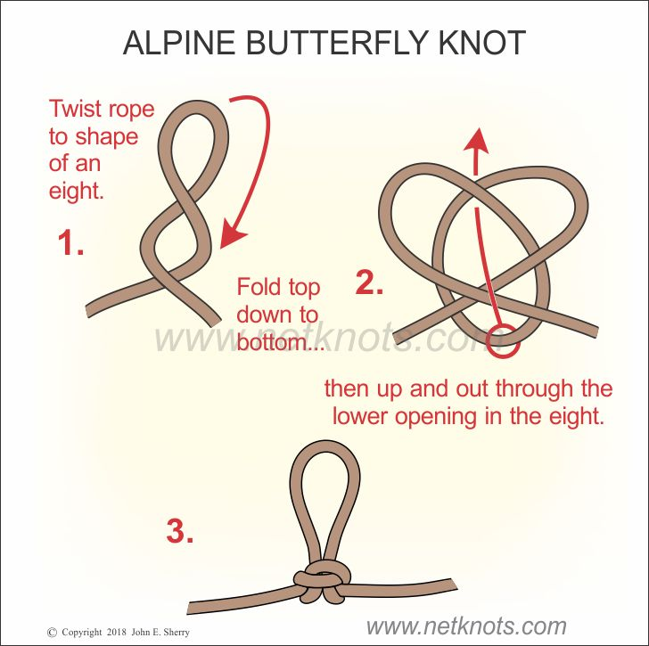
Please review this slide in preparation for performing the steps necessary to onboard OSCAR or a similar heavy object from the dock. You have already identified the steps you think will work for your boat. This exercise tests your draft procedures in a simulated emergency situation. Test other options if they are simpler or you find work better for your team. All crew should participate in the setup, rigging, clipping, and hoisting required to onboard a simulated PIW. Once a successful final series of steps has been identified, document them and create a formal action plan to be posted onboard for reference.
Consider a short video to review with your crew in the future and also to submit to the CCA with your course evaluation.
Note: Now is also a good time to inspect your LifeSling. Has it been degraded by UV exposure? How about the haul line? Anything need replacing? Another consideration is to add a butterfly knot as a lifting point on the yellow haul rope.

Slide 11: On-the-Water Boat Handling Exercise
As with the at-the-dock exercise, here is the outline for your on-the-water evolutions. Every crew member should have a defined task, but take turns with various positions as someone will be missing. Mistakes, confusion and nervousness are important to the evolutionary process of mastering the skills. Document these steps for future reference.
The result should be defining the boat handling steps that work best on your boat with your team. Once you have a final plan established - practice, practice, practice. Everyone should feel comfortable with the process.
Consider a short video to review with your crew in the future and also to submit to the CCA with your course evaluation.

Slide 12: 11 Step MOB Rescue Process - Review
Again this is the CCA recommended 11-Step MOB Rescue Process. After you have your plan established, review this with your crew. Post it along with your specific rescue procedures.

Slide 13: Sample VHF and MOB Placard
Post a placard with your MOB Rescue Procedure and VHF DSC Distress Call Procedure at the Nav station, at the helm and other pertinent locations. Posting in the head is a good spot for frequent reads.

Slide 14: Congratulations
Thank you for completing this man overboard rescue course. We hope that the competence of you and your crew in dealing with a serious rescue situation has significantly improved. While we are never fully prepared, you now have a set of tested procedures for you and your boat.
Please complete the course evaluation form so we can continually improve our course materials. Your feedback will help improve safety at Sea training for everyone. Return the feedback form and videos online to achieve recognition status.

